RUSSELL VILLAS TRANSPORTATION
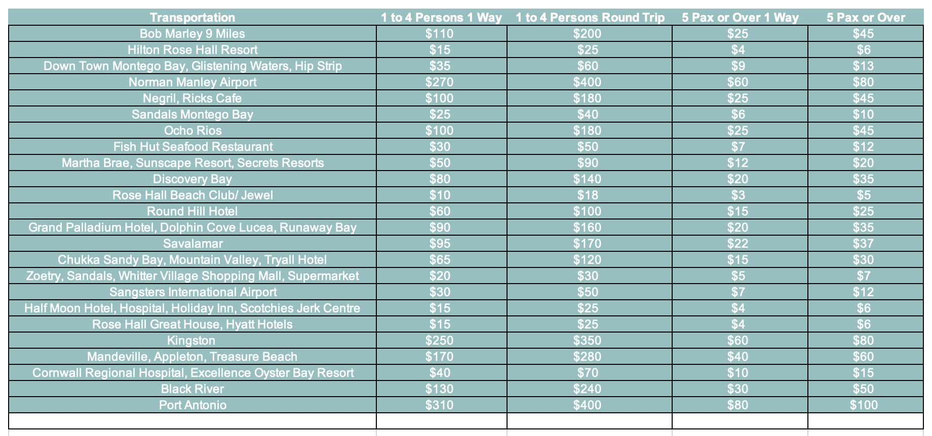
OUR RECOMENDED DRIVERS:
ANDY: SMALL AND LARGE GROUPS 1-16 1 COMPLEMENTARY AIRPORT PICK BASED ON AVAILABILITY
TEL: 876-804-7493 RUSSELL VILLAS IS NOT RESPONSIBLE FOR TRANSPORTATION

TONY: SMALL GROUPS 1-5 ALL OUR TRANSPORTATION OPPERATORS ARE OUTSOURCED
TEL: 876-503-5103 PRICES ARE FIXED

